- Testing

Basically, testing is the main part where we can check the data, that this software (data) is working well and completing all the mentioned requirements in a positive way. Let’s talk about the ways of testing the program. There are three main categories of checking whether the program is running properly or not, and these are:
- Normal: The normal data is all about the normal standard orders that customers do on a daily basis with all correct information. (e.g. a person ordering 2 large pizzas with the right details (name, address, toppings)).

- Boundary: The boundary data is all about checking the orders within given limits. It basically should follow the rules of validation within the required given scenario. (e.g. customer can order pizzas from 1 to 6; it will check the order must be between 1 to 6 and should not be above).

- Abnormal: The abnormal data is all about testing the data that customer puts out of the box or leaves the space blank. (e.g. customer did not put anything in the space where name should be mentioned or put a comma instead of mentioning pizza’s quantity (number)).
So, the software was checked by using a calculator before running the actual software, just for checking and verifying that the order totals, discounts, and fees are correct and working on the exact spot and providing the correct output.
For checking all of the required tests and outputs, the default customer details (Name: Alex Taylor, Address: 10 High Street, Phone: 07700 900123) were used.

4.1 Test plan and results:
# | Type | Purpose and test data | Expected results | Actual results | Result
1 | Normal | Standard 2 pizza order.  2x medium special (£5.50 each), collection. | Subtotal: £11.00  Total = £11.00 | Displaying:  Subtotal: £11.00  Total = 11.00 | PASS
2 | Normal | Order over £20 can have discount.  3x large (7.15 each) + 3 extra toppings (£0.75 each) + Delivery (£2.50). | Subtotal: £23.70; 10% Discount (£2.37); Delivery £2.50; Total £ 23.83. | Subtotal £23.70 shown; Discount £2.37 applied; Total £23.83 output | PASS
3 | Normal | Check customer contact details show on receipt.  Standard test details (Alex Taylor). | Name, address, and phone number shown clearly at top of receipt. | Details printed correctly on the receipt. | PASS
4 | Boundary | Minimum allowed pizza limit (1 pizza).  1x Small Margherita (£3.50). | Program accepts input; Total £3.50. | Accepted; Total £3.50 printed. | PASS
5 | Boundary | Maximum allowed pizza limit (6 pizzas).  6x Small Pizzas (£3.50 each = £21.00). | Program accepts 6 items; applies 10% discount (£2.10); Total £18.90. | Accepted; 6 items listed; Total £18.90 showed. | PASS
6 | Boundary | Exact discount threshold boundary (£20.00 subtotal).  4x Medium Pizzas (£5.00 base = £20.00). | Exact discount threshold boundary (£20.00 subtotal).  4x Medium Pizzas (£5.00 base = £20.00). | Total £20.00 output without discount deduction. | PASS
7 | Boundary | Subtotal just above discount threshold (£20.15).  4x Medium (£5.00) + 1 topping (£0.15). | 10% discount applied (£2.02); Total £18.13. | Discount applied; Total £18.13 output. | PASS
8 | Boundary | Pizza count below minimum limit.  0 pizzas, then 2 pizzas. | Show error message "Must be between 1 and 6!" and ask again. | Error displayed; system asked again for valid count. | PASS
9 | Boundary | Pizza count above maximum limit.  7 pizzas, then 2 pizzas. | Show error message "Must be between 1 and 6!" and ask again. | Error displayed; asked again for valid count. | PASS
10 | Abnormal | Blank Customer Name.  Press Enter with no text, then enter "Alex Taylor". | Show error message "This cannot be blank!" and ask again. | Warning displayed; input asked again until valid. | PASS
11 | Abnormal | Address made of spaces only.  Press spacebar (" "), then enter valid address. | Reject input as blank; show error and ask again. | Rejected with warning message; program continued safely. | PASS
12 | Abnormal | Invalid menu choice selected.  Select Pizza ID 99, then select valid ID 1. | Show error "Invalid choice. Please select from menu" and ask again. | Rejected with clear message; re-prompted user. | PASS
13 | Abnormal | Letters typed into numeric quantity field.  Type "uhn", then enter 2. | Handle invalid data type safely without crashing program. | Flowgorithm input window highlighted invalid type and re-asked. | PASS
  - Worked Calculation (Test 2):
Just for making sure, here are some manually hand/calculator-based calculations before running the actual test. This calculation has been done for comparing our data with software’s output that would help to maintain the accuracy of any specific output.
ID | Items/orders | Prices
2 | Large Pepperoni Pizza (3x (£7.15 each)) | £21.45
- | Extra Toppings (3x (£0.75 each)) | £2.25
- | Subtotal | £23.70
- | 10% Discount (Subtotal > £20.00) | -£2.37

ID | Services | Price
- | Delivery fee | £2.50
- | Total Cost (3 pizzas + Delivery applied) | £23.83

  - Evidence:
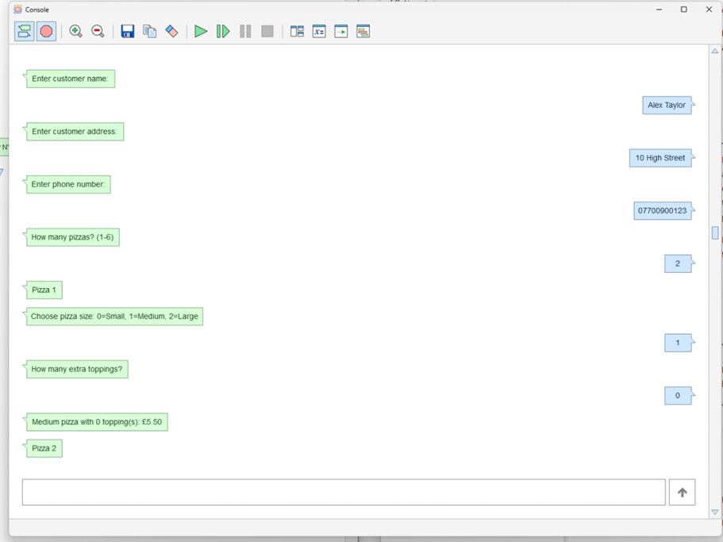

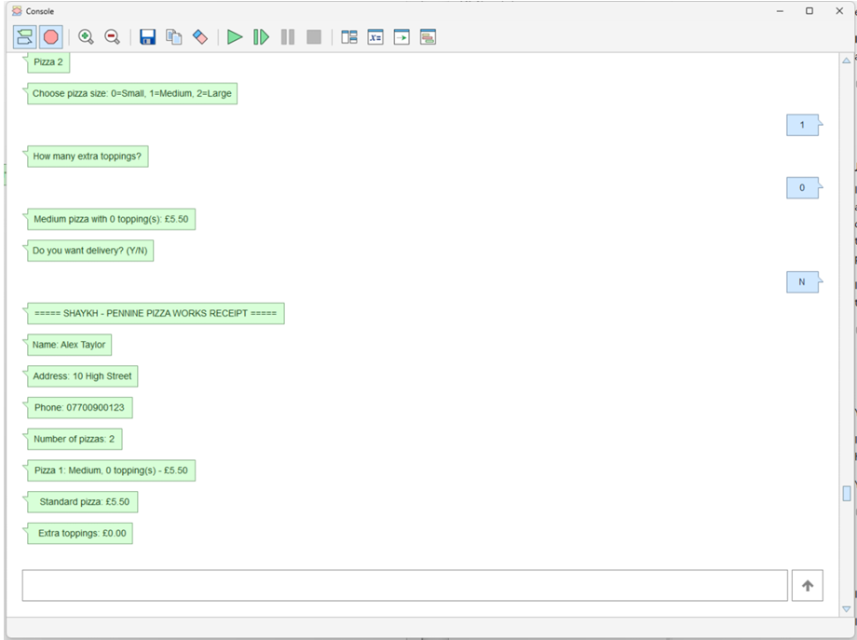
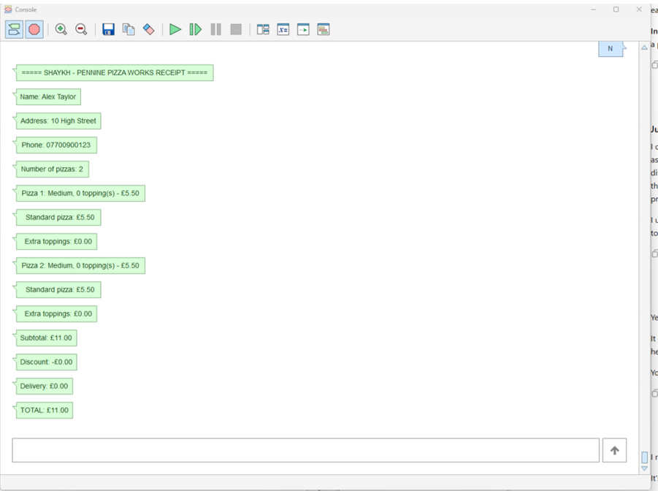
Figure 4.1: Normal test case: This test is showing that the system is entering everything correctly and giving the correct output after calculating the entered information, but this test is without delivery.
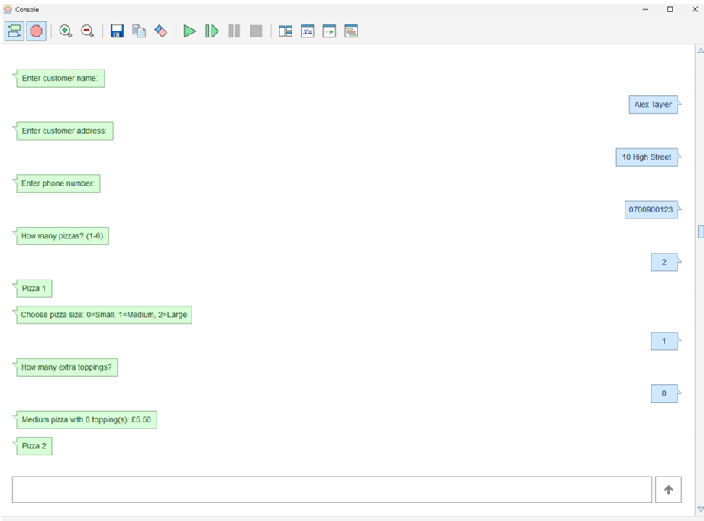
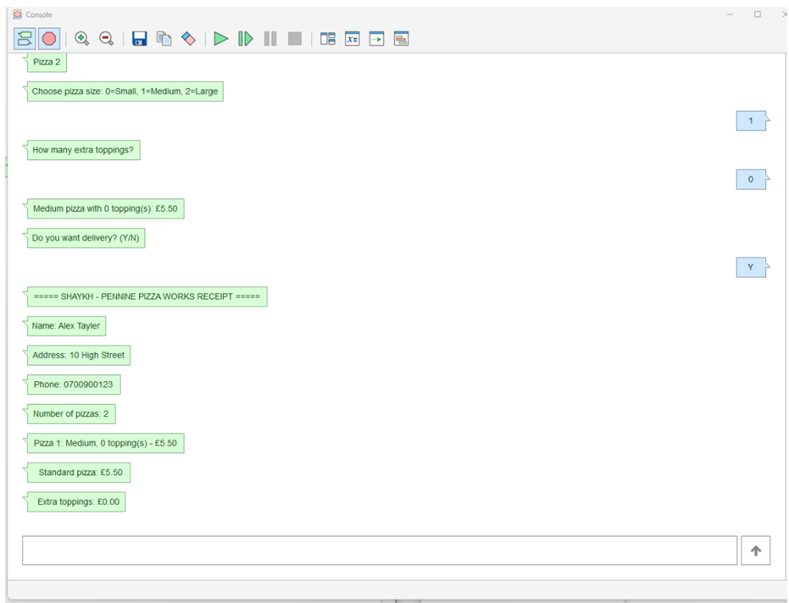

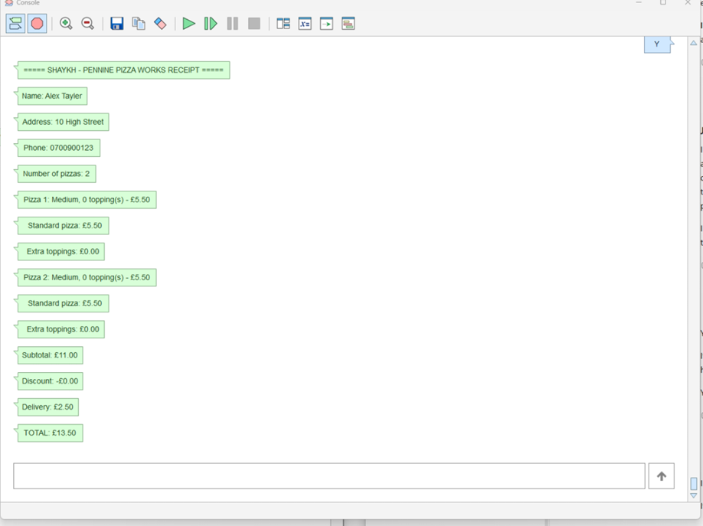
Figure 4.2: Normal test case: This test is showing that the system is entering everything correctly and giving the correct output after calculating the entered information, but this test is adding the delivery.

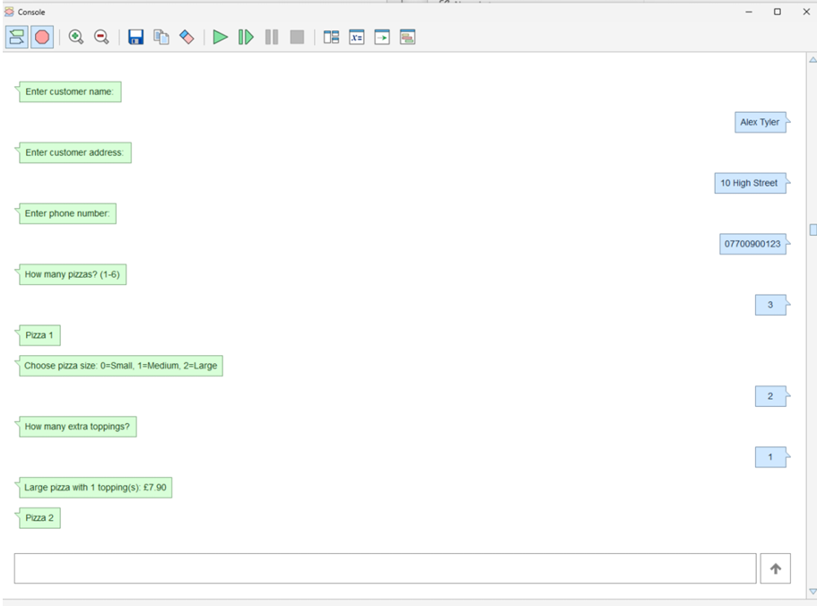
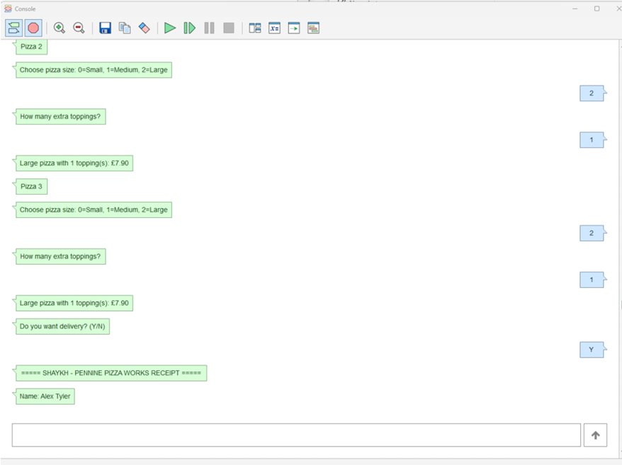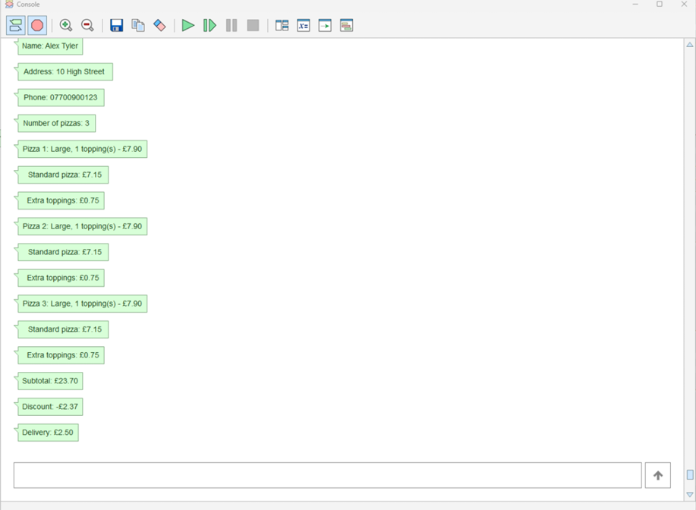

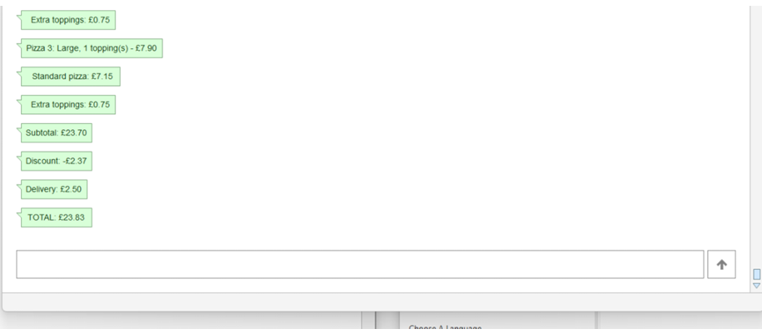
Figure 4.3: Normal test case: This test is showing that the system is entering everything correctly and giving the correct output after calculating the entered information, but this test is adding the delivery.

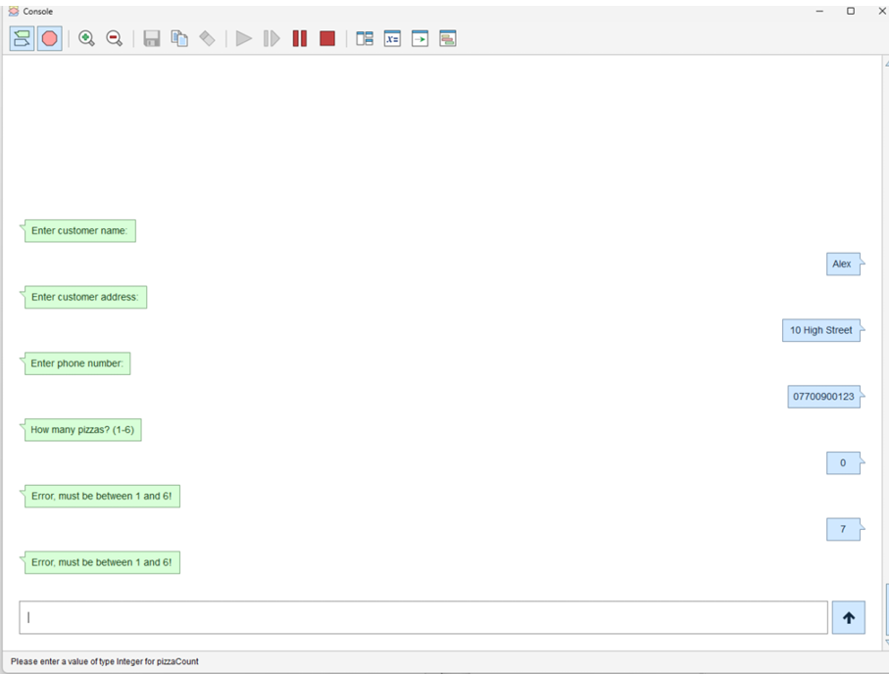
Figure 4.4: Boundary & Range Validation Case: This boundary test is checking the total limit of pizza ordering. It is giving error message on entering the wrong input (out of range/limit). And that is correct output.

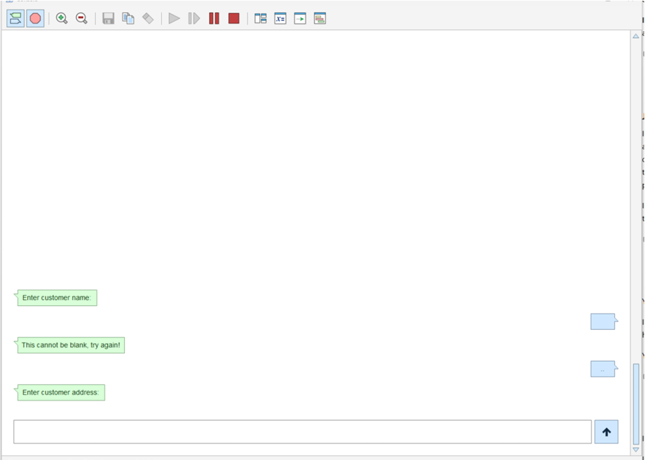
Figure 4.5: Abnormal Case: This is the case test where empty space entered, and the system shows error message which is correct output. But when double dot entered it is not giving error even system is asking the next question, which is not correct output. That is actually a bug that needs to be corrected.

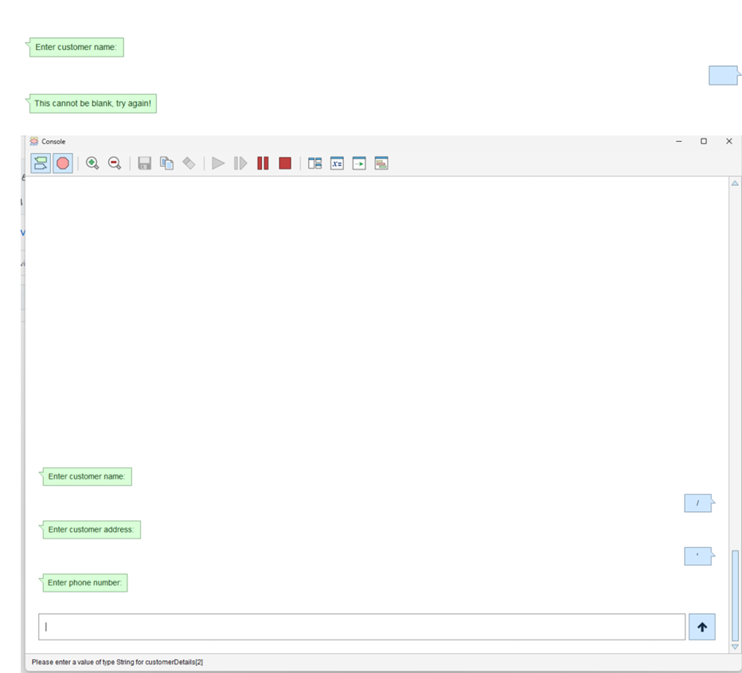
Figure 4.6: Abnormal Case: The slash (/) and dot (.) are entered it is not giving error even when the system is asking the next question, which is not correct output. That is actually a bug that needs to be corrected.

  - Issues found and recommended fixes
Finding out errors and bugs in the program can prove that the program has been running and testing properly and after this part the software would be able to fix and easily correct bugs after applying specific solutions on them. So, here is the list of errors while testing and explanation of resolving those issues by applying different strategies.

Found by | Issue | Recommended fix
Test 4 (R7) | The error is that the program is not showing subtotal and delivery charges separately. | We are adding output in (displaybill) function in this way it would show clearly subtotal and delivery charges.
Test 11 (R10) | The issue in program is accepting the input even the user entering “ ” in address. | We added string validation that will avoid the blank spaces and reject the entry.
Test 13 (R10) | The issue is program is not giving error if the letters are putting in pizza quantity section instead of numbers. | We putted input validation loop that asks input again on entering nonnumeric input.
Review (R9) | The problem is pizza prices are not showing the decimal places format correctly. | We added ToFixed(price, 2) that will always show 2 decimal places.

  - Requirements coverage:
ID | Requirement (Short) | Tested by | Status
R1 | Customer details entered (Name, Address, Phone) | 3,10,11 | Met
R2 | Quantity of pizzas selected (1–6) | 4, 5, 8, 9, 13 | Met
R3 | Pizza choices selected from menu | 1, 2, 4, 5, 12 | Met
R4 | Base price covers standard size | 1, 4, 6 | Met
R5 | Total order cost calculated | 1, 2, 6, 7 | Met
R6 | Customer details displayed on bill | 3 | Met
R7 | Detailed bill with subtotal & delivery charge | 2, 6, 7 | Met
R8 | Breakdown and total cost shown | 1, 2, 6, 7 | Met
R9 | Prices shown with two decimal places (£0.00) | 1, 2, 6, 7 | Met
R10 | reject invalid input automatically. | 8, 9, 10, 11, 12, 13 | Met
R11 | Clear user-friendly messages | 8, 9, 10, 12 | Met
R12 | Clean code and standard formatting | Section 3 | Met

